FINAL PROJECT DOCUMENTATION

Restaurant Inventory & Sales BI Dashboard

1. Cover Page
Project Title: Capstone-Integrated BI Dashboard
Capstone System Name: Development of Sales and Inventory System with QR Code-Based Ordering and Predictive Analytics
Student Name(s): Dionisio Alvior, Justine Reyes, John Mark Ordiales, Jozel Venturina
Course & Program: BSIS – 4th Year
Instructor: Angel Orendain
Date: February 25, 2026

2. System Overview

What the Capstone System Does
The system is a comprehensive Sales and Inventory Management Solution featuring QR code-based ordering for streamlined restaurant transactions and predictive analytics to forecast stock requirements and sales trends.

Target Users
- Restaurant Staff / Cashiers
- Inventory Managers
- Business Owners

Type of System
Sales & Inventory System with QR Code Ordering and Predictive Analytics

Database Used
PostgreSQL

3. Data Source & Integration

Data Origin
The data was exported from the Capstone System in CSV format to ensure seamless integration into Power BI.

Tables Used
Dimension Tables:
- dim_ingredients – Master list of ingredients and current stock levels
- dim_products – List of menu items and product categories
- dim_recipes – Mapping of products to required ingredients
- dim_users – Staff roles and account details
Fact Tables:
- fact_sales – Detailed transaction records
- fact_inventory_counts – Physical stock count records
- fact_stock_transactions – Stock movement (incoming/outgoing) records
- fact_waste – Spoiled or lost inventory records

Primary Key – Foreign Key Relationships
- dim_products[Product_ID] → fact_sales[Product_ID]
- dim_ingredients[Ingredient_ID] → fact_stock_transactions[Ingredient_ID]
- dim_ingredients[Ingredient_ID] → fact_inventory_counts[Ingredient_ID]
- dim_ingredients[Ingredient_ID] → fact_waste[Ingredient_ID]
- dim_products[Product_ID] → dim_recipes[Product_ID]
- dim_ingredients[Ingredient_ID] → dim_recipes[Ingredient_ID]
Dimension tables contain the Primary Keys, while fact tables contain the corresponding Foreign Keys.

Date Fields Used
- fact_sales[Order_Date]
- fact_inventory_counts[Date]
- fact_stock_transactions[Date]
- fact_waste[Date]
A centralized Calendar table was created in Power BI to standardize time-based analysis.

Data Integration Screenshots
Database Tables / ERD / Power BI Data Model (Relationships View)::
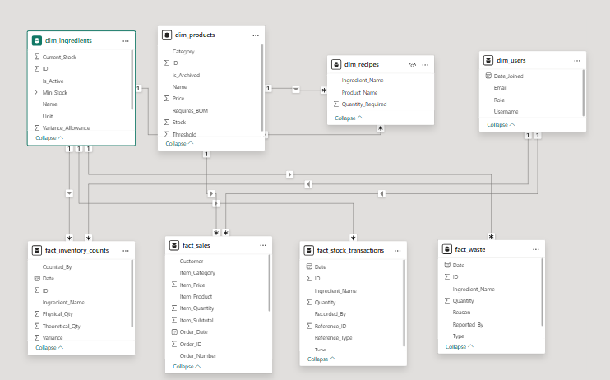

4. Data Preparation

Data Cleaning Steps (Power Query)
- Header Promotion – Ensured all CSV columns were properly identified as headers.
- Data Type Correction – Converted numerical strings to Whole Numbers or Decimals and formatted Date columns properly.
- Text Cleaning – Trimmed leading and trailing spaces from text fields.
- Calendar Table Creation – Created a DAX Calendar table for consistent time-series reporting.

DAX Measures Created
- Total Sales Revenue:
SUM(fact_sales[Total_Amount])
- Total Orders:
DISTINCTCOUNT(fact_sales[Order_ID])
- Low Stock Count:
COUNTROWS(FILTER(dim_ingredients, dim_ingredients[Current_Stock] <= dim_ingredients[Min_Stock]))
- Total Waste:
SUM(fact_waste[Quantity])

KPIs Created
- Revenue Trend (Daily Sales Performance)
- Stock Health (Low Stock Monitoring)
- Waste Monitoring
- Average Order Value

Data Preparation Screenshots
Power Query Editor:
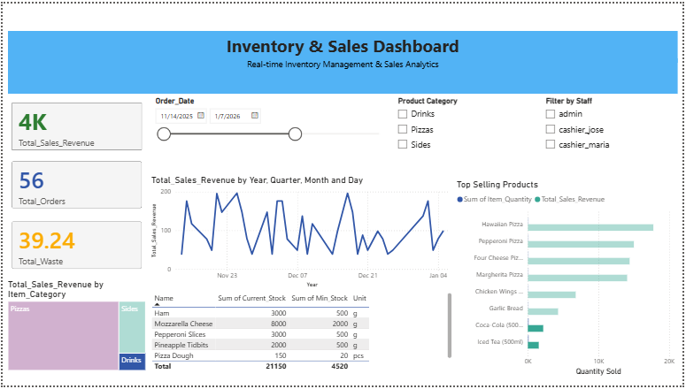

Relationships View:

5. Screenshot Comparison (Mandatory)
Capstone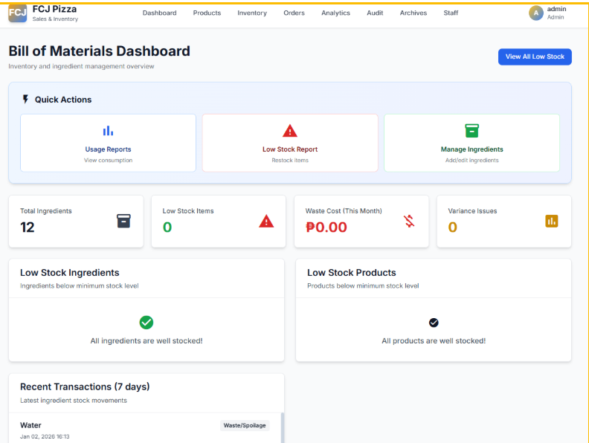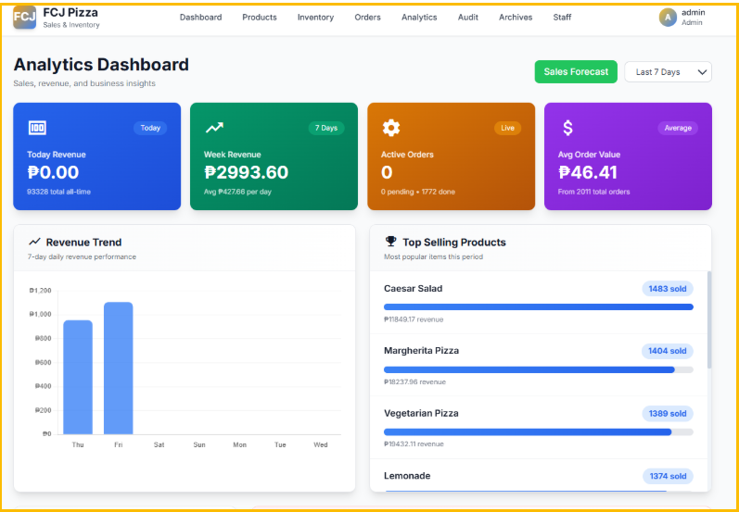

Power Bi
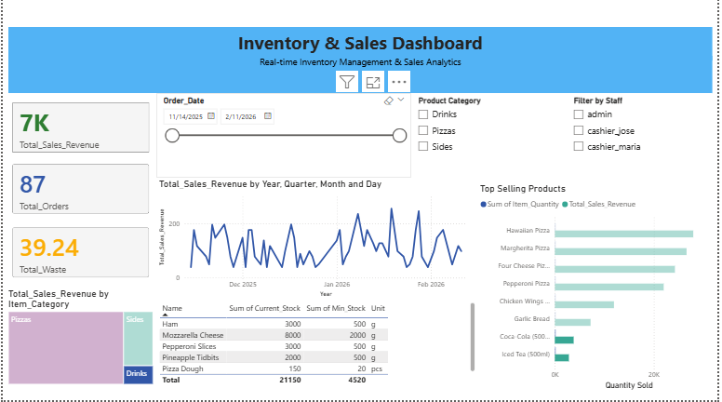

6. Dashboard Overview

Full Dashboard View

Slicers & Interactivity
- Date Slicer – Filters all visuals based on selected time period
- Category Filter – Filters performance by product category (Pizza, Drinks, Sides)
- Drill-Down Function – Allows users to explore product-level ingredient usage and waste data

Decision Support Capabilities
The dashboard enables management to:
- Identify peak revenue periods
- Monitor low stock levels in real time
- Analyze waste trends
- Evaluate product performance
- Improve restocking and promotional strategies

7. Insights & Recommendations

Key Insights
- Peak Sales Period
The highest recorded revenue was ₱254.00 on January 19, 2026. January shows a stronger revenue trend compared to late 2025, with multiple peaks exceeding ₱200 (January 8, 19, and 28).
- Product Volume vs Revenue
Caesar Salad is the top-selling item by volume (1,483 units sold). However, Vegetarian Pizza is the highest revenue contributor, generating ₱19,432.11 despite ranking third in quantity sold.
- Average Order Value
The current Average Order Value (AOV) is ₱46.41. Strong side-item sales such as Lemonade (1,374 units sold) indicate a high attachment rate between main dishes and beverages.

Recommendations
- Inventory Preparation for January
Increase stock buffer levels beginning mid-December to prepare for recurring January revenue peaks, particularly between January 19–28.
- Menu Optimization Strategy
Promote a “Vegetarian Bundle” combining Vegetarian Pizza and Caesar Salad to increase the Average Order Value from ₱46.41 to above ₱50.
- Targeted Marketing Strategy
Use QR code ordering data to send targeted promotions during slower sales days (Saturday–Tuesday trend) to balance demand throughout the week.

